Conducted by Mr. Chiv Hak, Mr. Ratanak, and Mrs. Chandavy

Date: 15-06-2016

Collateral and Business View

1. **The charged properties’ location**

Address: Trapaing Lvea Village, Kakab Commune, Por Senchey District, Phnom Penh.

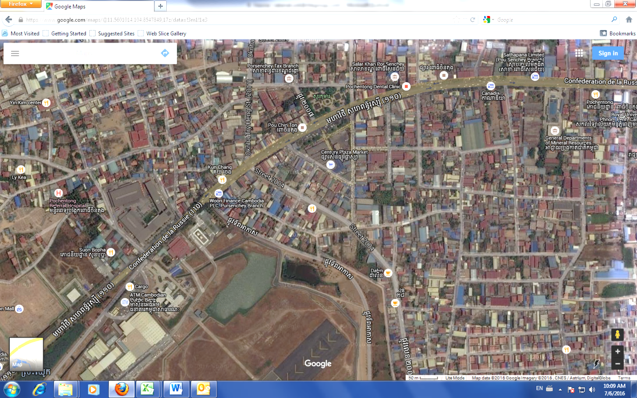

Century Plaza Market

Subject Property

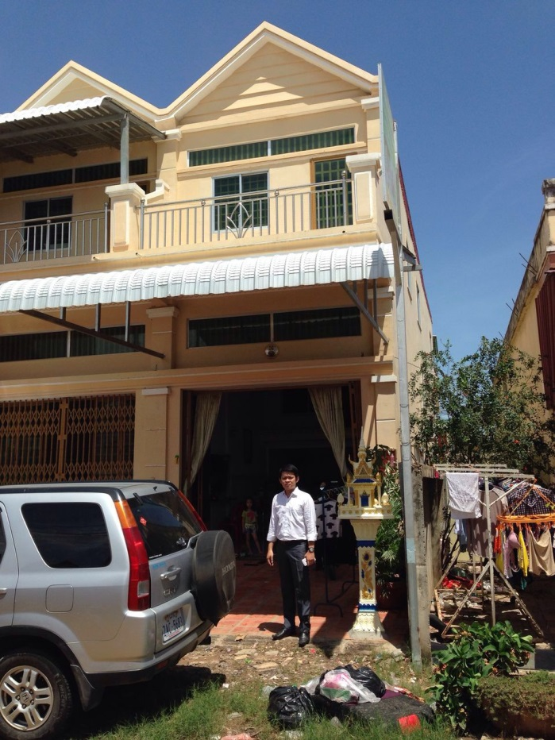

**Subject Property**

1. Premise Business: Camfone Mobile Shop

Address: No. 30Eo, Street 374, Sangkat Toul Svay Prey 2, Khan Chamkarmon, Phnom Penh.

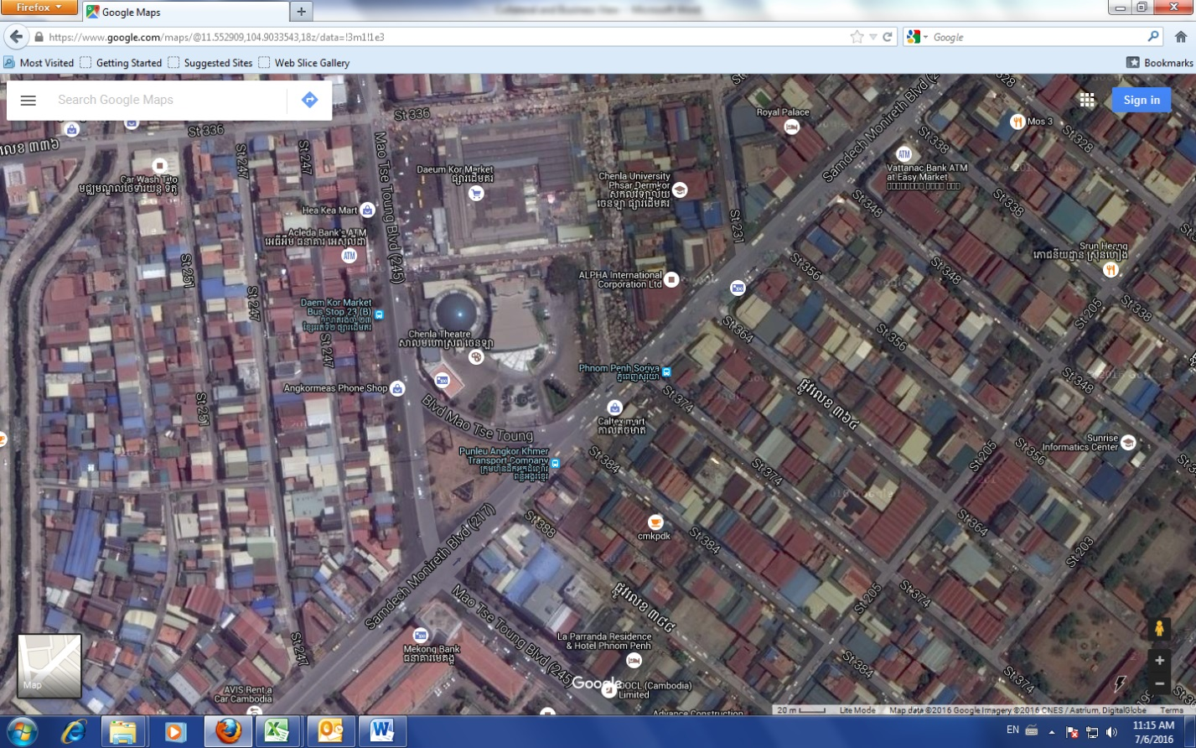

Business Premise & Resident

Derm Kor Maket

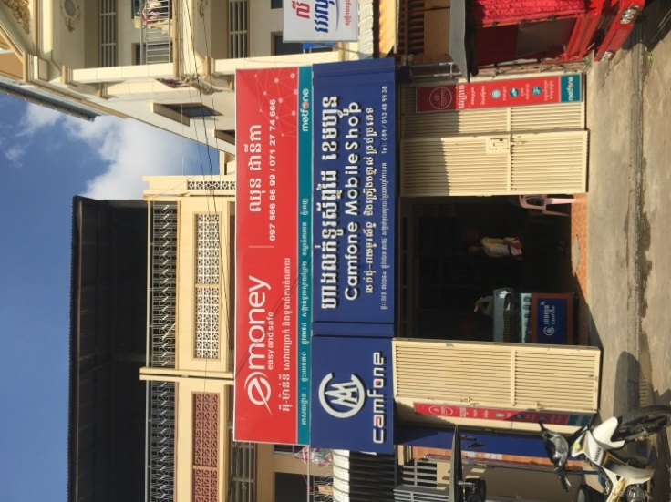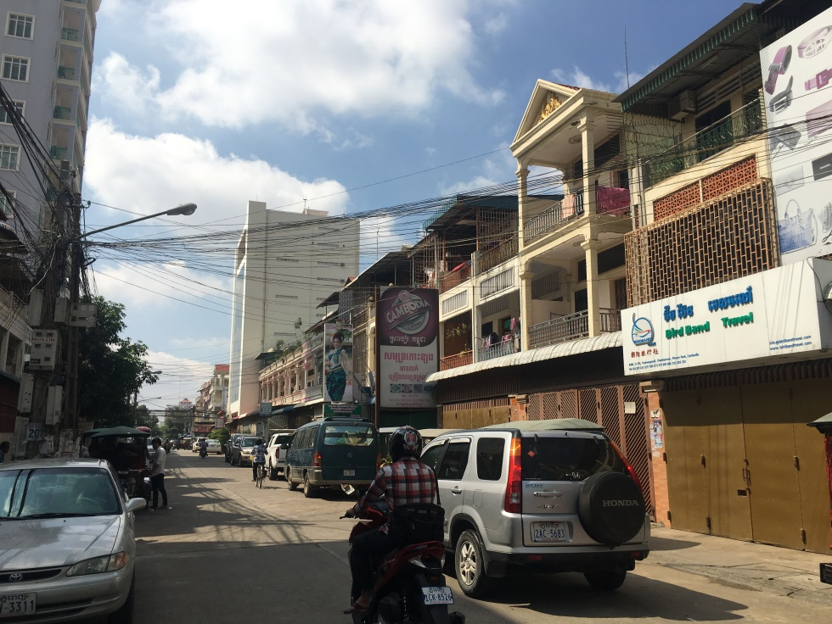

**Street 374**

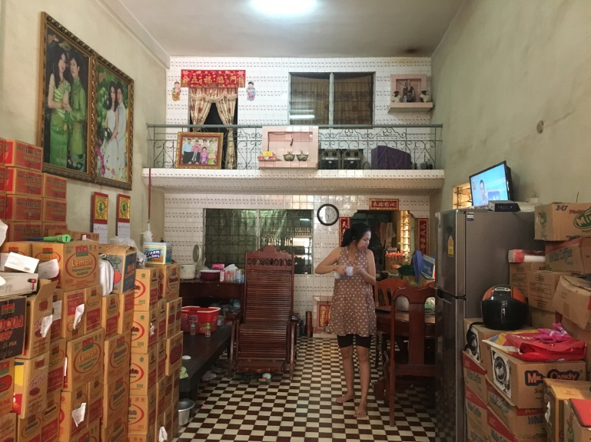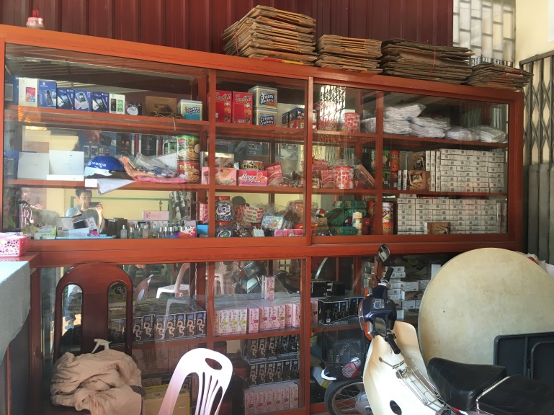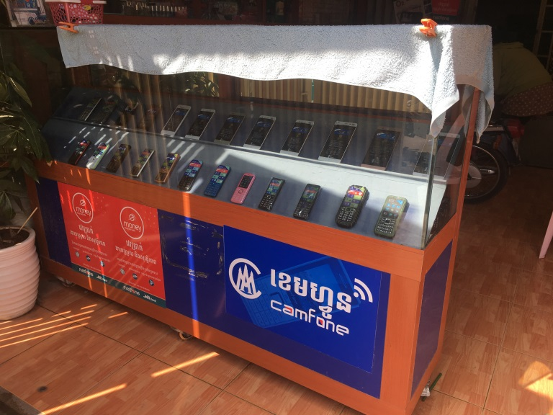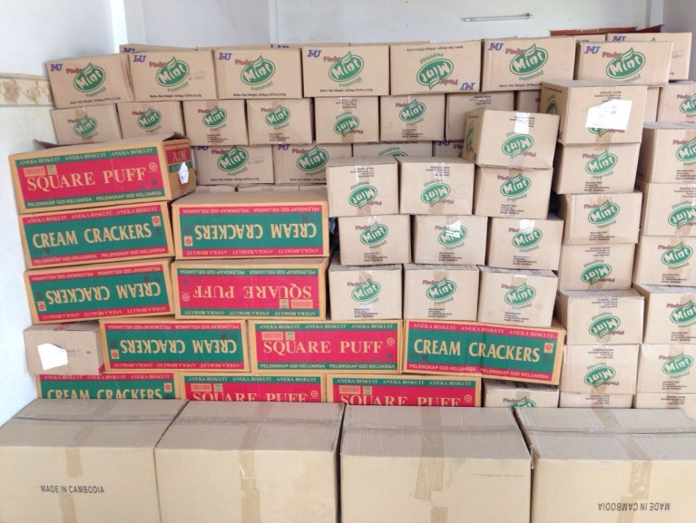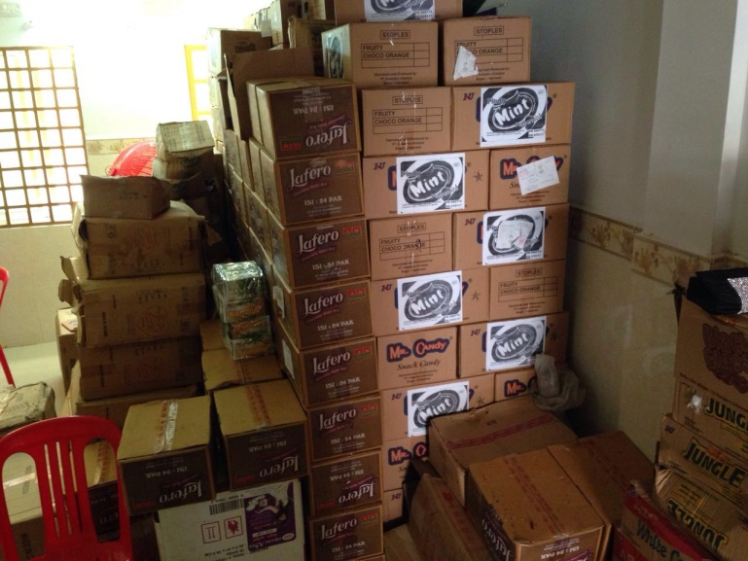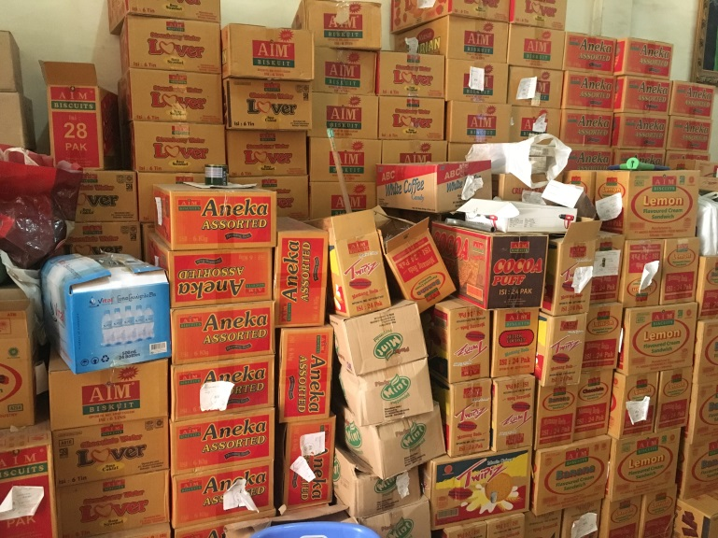

1. Rama Holding Group Ltd.

Address: No. 104, St. 296, S/K. Toul Svay Prey 2, Khan Chamkarmon, Phnom Penh.

